**Practical-3:** Color styling effects and blending modes with Dark and Light Theme

**Definition:** Create a background for the Registration Form and Login Form using Blending Modes, color style, and color gradients for light and dark mode backgrounds

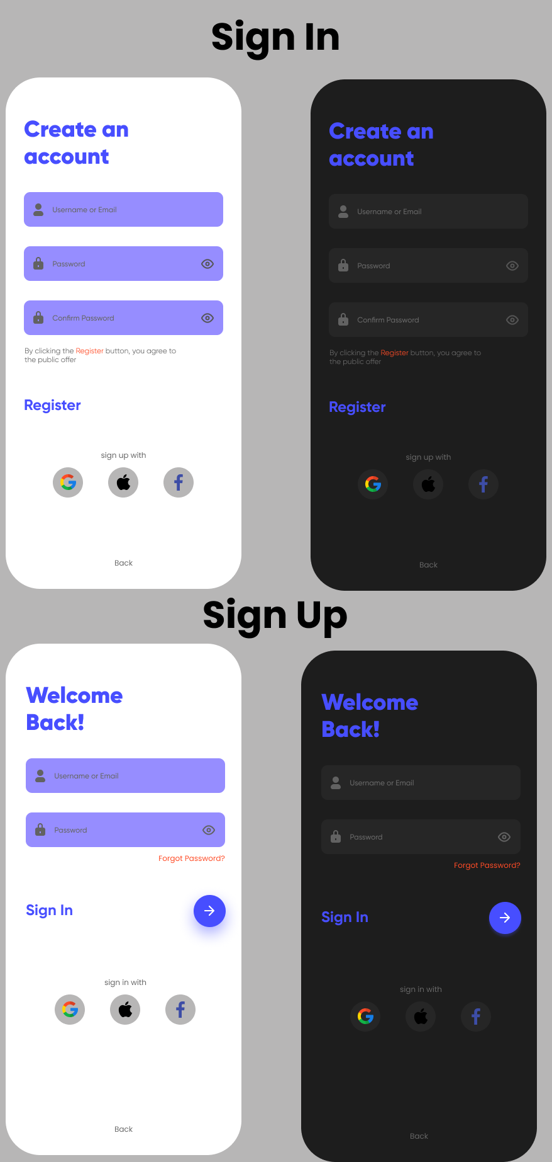**Solution:**

**Working:**

* First, open Figma. Add a new Figma design file.
* Rename a file as 133_Practical-3_SignScreens.
* In this design, the following tools are used for a particular operation:
* Export your design as a PNG file.

|  |  |  |
| --- | --- | --- |
| **Tools Name** | **Use** | **Properties** |
| **Frame Tool (F)** | Used as the mobile screen container for both Sign In and Sign Up screens. | Width: 386px, Height: 791px  Corner Radius: 30px for rounded corners  Background color: #FFFFFF for light mode, #1C1C1C for dark mode Blend mode: Pass Through |
| **Rectangle Tool (R)** | Used to create the shape of the input fields and buttons. | Width: ~300px, Height: ~50px (for input fields)  Fill colors: #7D6BFF for light theme inputs, darker shades for dark theme  Corner Radius: 10px No stroke |
| **Ellipse Tool (O)** | Used to create the round button for the Sign In action (arrow button). | Diameter: 50px  Color fill: #7D6BFF (light purple) Apply a soft drop shadow for glow effect Rename as “Sign In Button” |
| **Text Tool (T)** | Used for all headings, labels, placeholder text, and links like “Register” or “Forgot Password?”. | Fonts: e.g. Poppins weights: Bold for titles, Regular for subtext Font sizes: varies (e.g. 26px for headings, 14-16px for subtext)  Colors: #000000 or #FFFFFF depending on theme |
| **Icon Tool / Vector Tool** | Used for icons inside input fields (like user, lock, eye icon) and social icons (Google, Apple, Facebook). | Icons size: 20-24px  Colors matching theme (#FFFFFF or #7D6BFF) Place inside input fields or social buttons  Rename layers like “Lock Icon,” “Google Icon,” etc. |
| **Auto Layout (Shift + A)** | Used to group input fields and arrange items vertically with consistent spacing. | Direction: Vertical Spacing between elements: 16px-24pxPadding: 16px around inputs/buttons |
| **Align Tools** | Used to align text, icons, and buttons neatly within the screen. | Align horizontal centers, left edges, or distribute spacing evenly Shortcut: Shift + H or Shift + V |
| **Color Styles** | Used to keep consistent color schemes for light and dark themes. | Light theme background: #FFFFFF  Dark theme background: #1C1C1C  Primary color: #7D6BFF Secondary text colors: gray shades, #FF5733 for error/alerts |
| **Layer Rename** | Helps keep all layers well organized for easier editing. | Examples: “SignIn_Header_Text,” “Email_Field,” “SignIn_Button,” etc. |
| **Export Tool** | To save the final design screens as images for submission. | Go to File → Export → JPG or PNG Choose desired resolution and quality |